|  |  |
| --- | --- |
|  |  |
| Analyzing Travel Insurance Data |  |
|  |  |
|  | 18/10/2021High Level Design |
|  | Anshul PandeyiNeuron Intelligence Pvt Ltd |

## Document Version Control

|  |  |  |  |
| --- | --- | --- | --- |
| Date Issued | Version | Description | Author |
| 18th Oct 2021 | 1.0 | First Version of Complete HLD  (Analyzing Travel Insurance Data) | Anshul Pandey |
|  |  |  |  |
|  |  |  |  |

Contents

Analyzing Travel Insurance Data 1

Document Version Control 2

Abstract 4

Introduction 5

Why this High-Level Design Document? 5

The HLD will: 5

Scope 5

General Description 6

Tools used 7

Design Functionality 8

High Level Design 9

Deployment 11

## Abstract

Finance is used as a collective term to refer to a broad range of economic services provided by

the finance industry, which encompasses a broad range of organizations that manage money,

including credit unions, banks, credit card companies, insurance companies, consumer finance

companies, stock brokerages, investment funds.

Little is known about travel insurance claims made by travelers returning from abroad. This study was designed to investigate travel insurance claims made by travelers from different countries, particularly examining demographic factors, type of travel insurance coverage, nature and duration of travel, when treatment was sought during travel or when the problem arose, use of emergency assistance, nature of claim, and claim outcome, including cost.

## Introduction

### Why this High-Level Design Document?

The purpose of this High-Level Design (HLD) Document is to add the necessary detail to the current project description to represent a suitable model for coding. This document is also intended to help detect contradictions prior to coding, and can be used as a reference manual for how the modules interact at a high level.

### The HLD will:

* Present all of the design aspects and define them in detail
* Describe the user interface being implemented
* Describe the hardware and software interfaces
* Describe the performance requirements
* Include design features and the architecture of the project

### Scope

The HLD documentation presents the structure of the system, such as the database architecture, application architecture (layers), application flow (Navigation), and technology architecture. The HLD uses non-technical to mildly-technical terms which should be understandable to the administrators of the system.

### General Description

#### Problem Statement

Finance is used as a collective term to refer to a broad range of economic services provided by the finance industry, which encompasses a broad range of organizations that manage money, including credit unions, banks, credit card companies, insurance companies, consumer finance companies, stock brokerages, investment funds.

Do ETL: Extract-Transform-Load the dataset and find for me some information from this large data.

This is form of data mining. What all information can be achieved by mining this data, would be brainstormed by the interns.

Find key metrics and factors and show the meaningful relationships between attributes. Do your own research and come up with your findings.

### Tools used

Business Intelligence tools and libraries works such as MS SQL Server, Excel, Python, Power BI are used to build the whole framework.

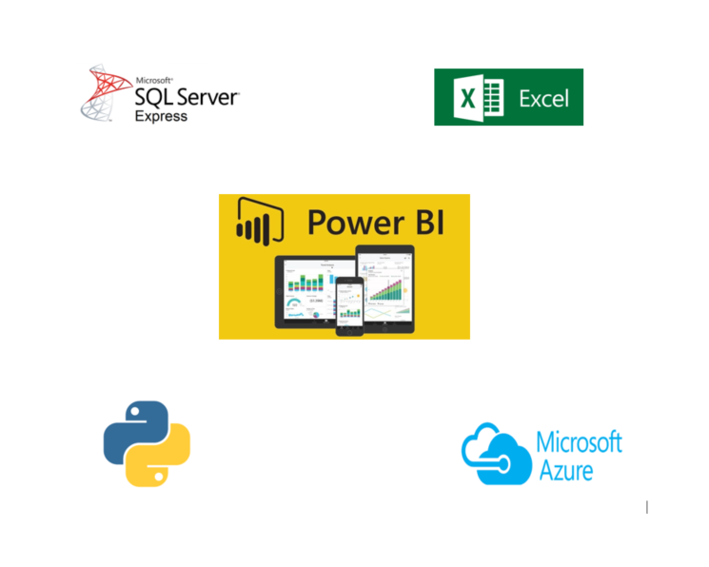

### Design Functionality

#### Business Intelligence Architecture

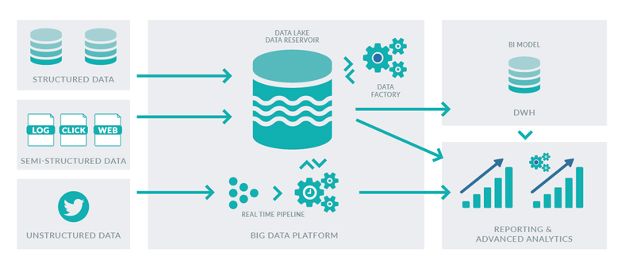

#### Power Bi Architecture

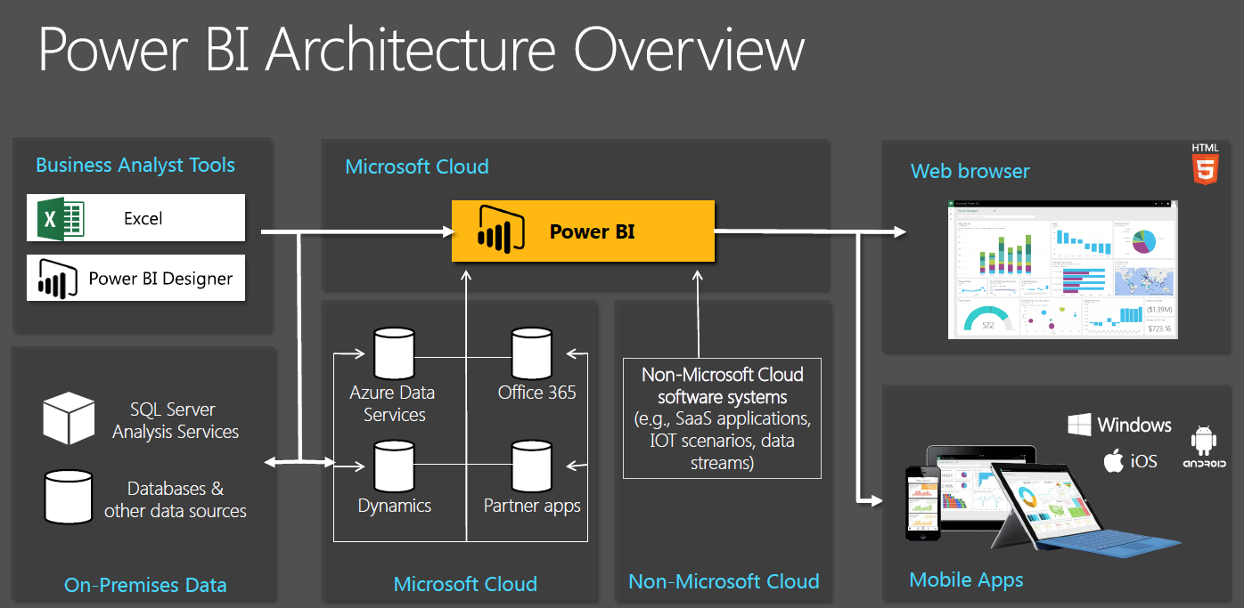

### High Level Design

#### Optimization

**Your data strategy drives performance**

* • Minimize the number of fields
* • Minimize the number of records
* • Optimize extracts to speed up future queries by materializing calculations, removing columns and the use of accelerated views

**Reduce the marks (data points) in your view**

* • Practice guided analytics. There’s no need to fit everything you plan to show in a single view. Compile related views and connect them with action filters to travel from overview to highly-granular views at the speed of thought.
* • Remove unneeded dimensions from the detail shelf.
* • Explore. Try displaying your data in different types of views.

**Limit your filters by number and type**

* • Reduce the number of filters in use. Excessive filters on a view will create a more complex query, which takes longer to return results. Double-check your filters and remove any that aren’t necessary.
* • Use an include filter. Exclude filters load the entire domain of a dimension, while include filters do not. An include filter runs much faster than an exclude filter, especially for dimensions with many members.
* • Use a continuous date filter. Continuous date filters (relative and range-of-date filters) can take advantage of the indexing properties in your database and are faster than discrete date filters.
* • Use Boolean or numeric filters. Computers process integers and Booleans (t/f) much faster than strings.
* • Use parameters and action filters. These reduce the query load (and work across data sources).

**Optimize and materialize your calculations**

* • Perform calculations in the database
* • Reduce the number of nested calculations.
  1. • Reduce the granularity of LOD or table calculations in the view. The more granular the calculation, the longer it takes. o LODs - Look at the number of unique dimension members in the calculation.
  2. o Table Calculations - the more marks in the view, the longer it will take to calculate.
  3. • Where possible, use MIN or MAX instead of AVG. AVG requires more processing than MIN or MAX. Often rows will be duplicated and display the same result with MIN, MAX, or AVG.
* Make Groups calculations. Like include filters, calculated groups load only named members of the domain, whereas Tableau’s group function loads the entire domain.
* • Use Booleans or numeric calculations instead of string calculations. Computers can process integers and Booleans (t/f) much faster than strings. Boolean>Int>Float>Date>Date Time>String

#### Data Model

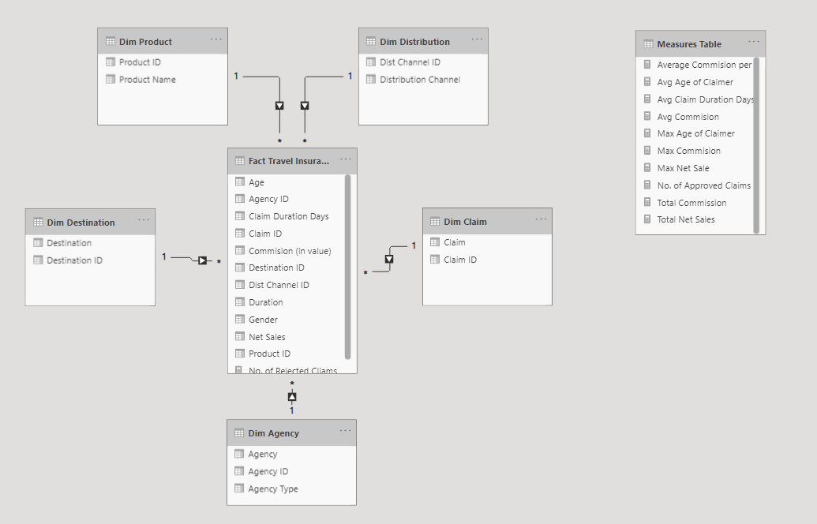

#### KPI’s

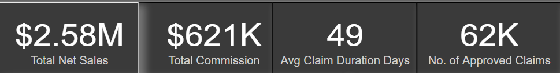

#### KPIs (Key Performance Indicators)

Key indicators displaying a summary of the Travel Insurance Claim Analysis

* Total Net Sales made by the Travel Insurance.
* Total Commissions Generated.
* Average Days take in approving Insurance Claims.
* No. Of Approved Insurance Claims Cases.
* Influence of Net Sales and Commission with Lower Demographics like Product Name, Countries.
* Commissions and Avg Net Sales by Agency.
* Influence of Agency Type.
* Influence of Distribution Channel.

### Deployment

Prioritizing data and analytics couldn’t come at a better time. Your company, no matter what size, is already collecting data and most likely analyzing just a portion of it to solve business problems, gain competitive advantages, and drive enterprise transformation. With the explosive growth of enterprise data, database technologies, and the high demand for analytical skills, today’s most effective IT organizations have shifted their focus to enabling self-service by deploying and operating Tableau at scale, as well as organizing, orchestrating, and unifying disparate sources of data for business users and experts alike to author and consume content.

Power BI prioritizes choice in flexibility to fit, rather than dictate, your enterprise architecture. Power BI Services and Power BI Desktop leverage your existing technology investments and integrate into your IT infrastructure to provide a self-service, modern analytics platform for your users. With on-premises, cloud, and hosted options, there is a version of Power BI to match your requirements.

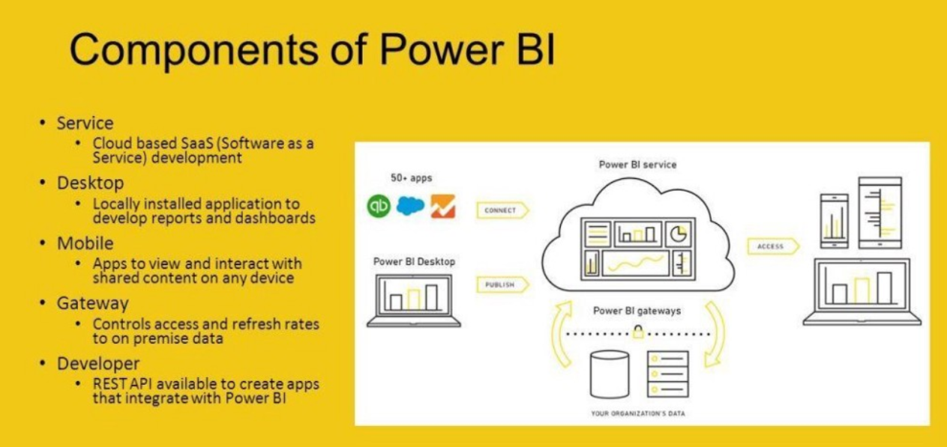

Power BI Components Comparison:

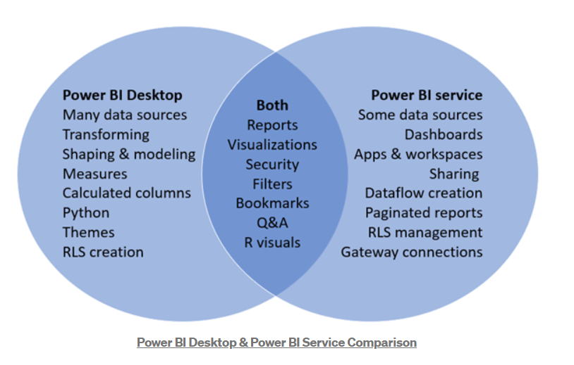

Depending on your organizational roles and responsibilities, Power BI Desktop and Workspace should be installed by a systems administrator and the designated Power BI Services Administrator in coordination with the appropriate IT roles. For Power BI Desktop and Workspace, you will integrate with your existing technology and configure the site settings. The Data & Analytics Survey, completed by business teams, identifies and prioritizes data use cases, audience size, and users. You will use the information collected in both surveys to plan your deployment strategy, including sizing, installation, and configuration of your Power BI Desktop and Workspace or integration and configuration of Power BI Desktop and Workspace. In addition to installing Power BI Desktop and Workspace or configuring Power BI Desktop and Workspace, administrators will also need to plan for the client software installation of Power BI Desktop (Power Query), Power BI Desktop, Power BI Mobile, and Tableau Bridge Power BI Desktop and Workspace where applicable.